DOCKER COMPOSE

* Sudo su –
* Yum install docker -y
* Systemctl start docker
* Download the docker compose binary
* sudo curl -L "[https://github.com/docker/compose/releases/download/$(curl](https://github.com/docker/compose/releases/download/$(curl" \t "_blank" \o "https://github.com/docker/compose/releases/download/$(curl) -s [https://api.github.com/repos/docker/compose/releases/latest](https://api.github.com/repos/docker/compose/releases/latest" \t "_blank" \o "https://api.github.com/repos/docker/compose/releases/latest) | jq -r .tag\_name)/docker-compose-$(uname -s)-$(uname -m)" -o /usr/local/bin/docker-compose
* Copy this link in compose binary file and paste it this link
* Apply executable permissions
* sudo chmod +x /usr/local/bin/docker-compose
* Verify installation

* 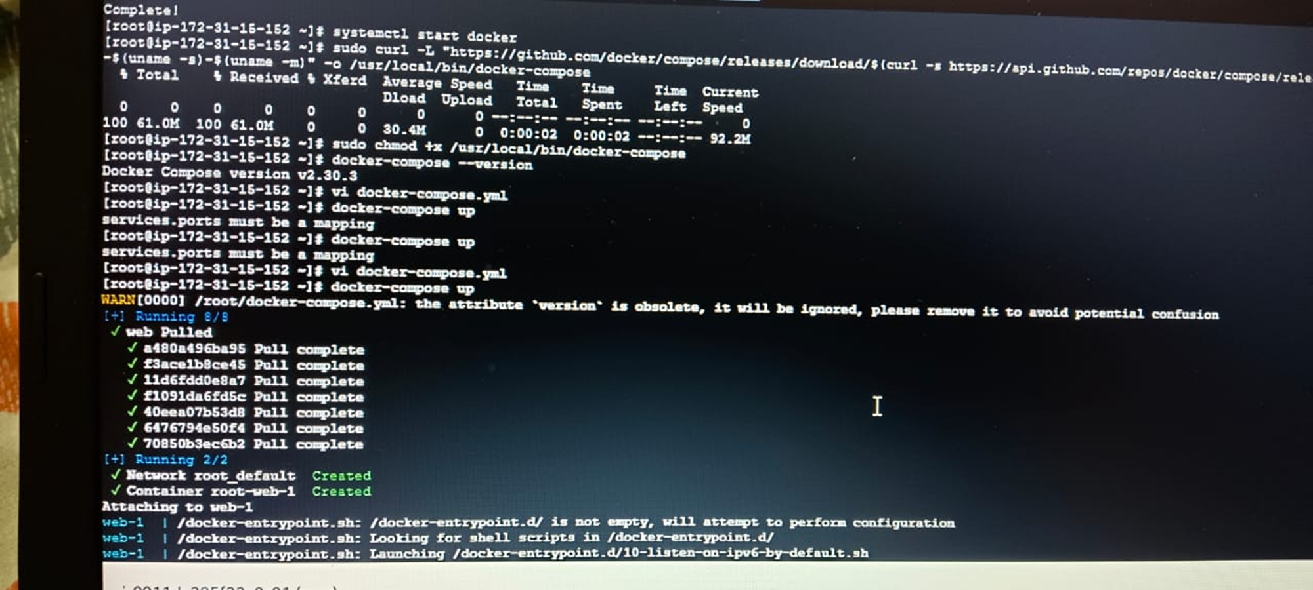

Vi docker-compose.yml

* Service start
* docker-compose up
* GO TO SECURITY FILE ADD PORT NUM IN CUSTOMCTP AND PORTRANE 8000
* Run docker compose file
* docker-compose up -d its started
* See the all services
* Docker ps
* See images
* docker-compose images
* Docker-compose down it will stop and remove services
* docker ps
* 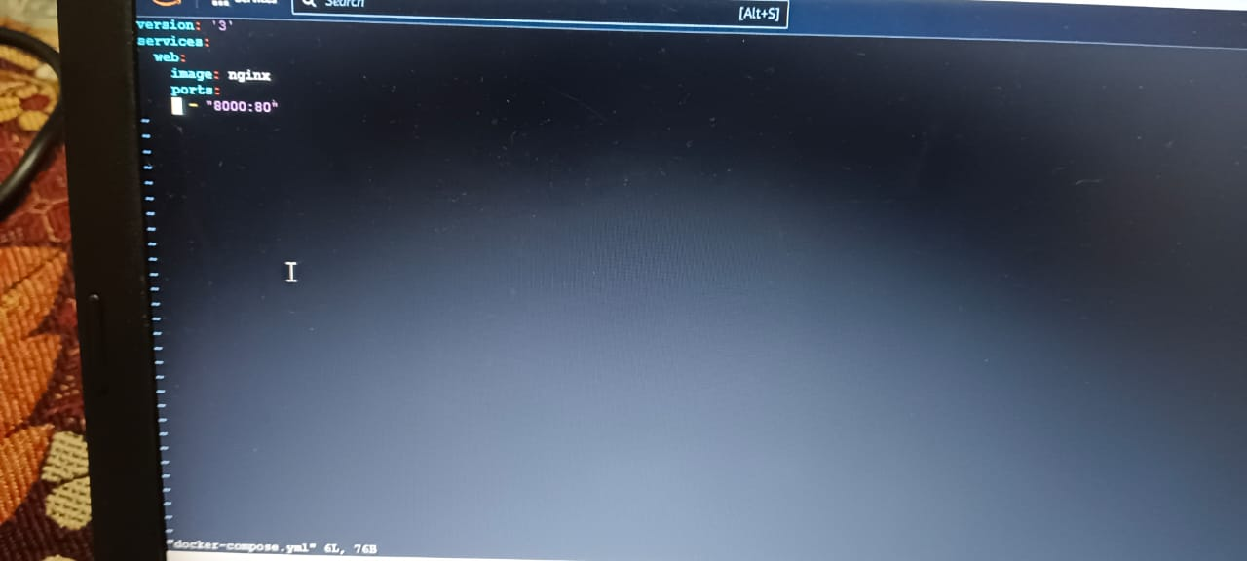

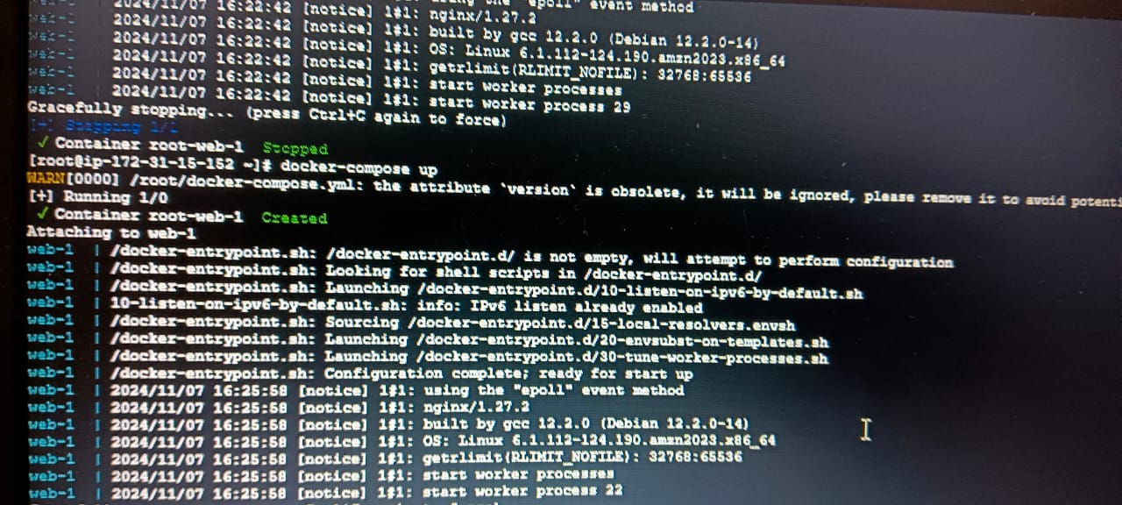

* docker- compose up -d
* docker ps
* GO TO SECURITY GROUP ADD ALL TRAFFIC
* 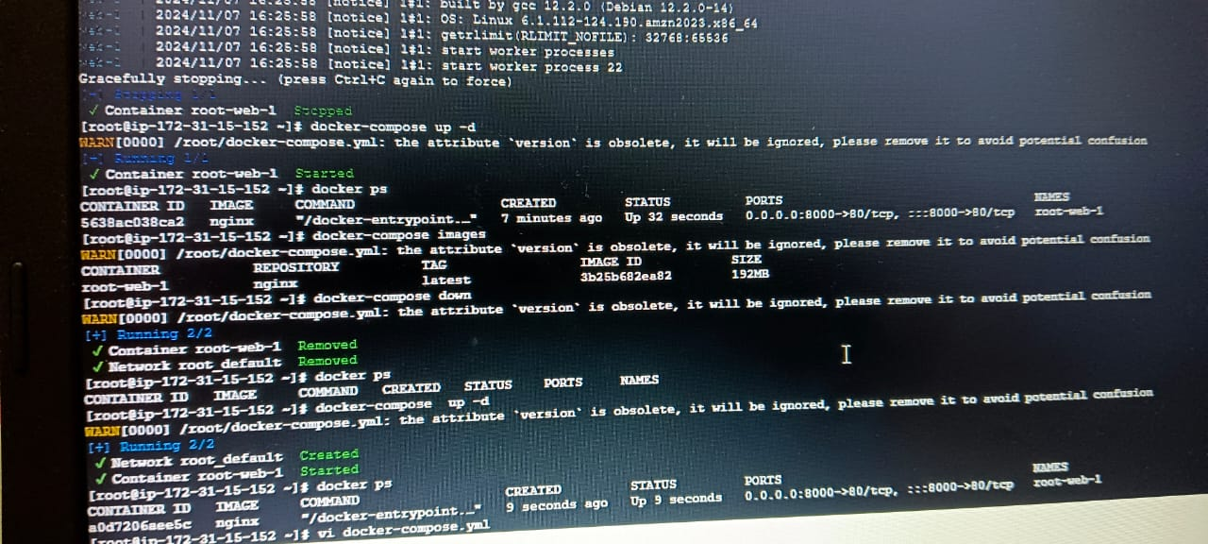
* 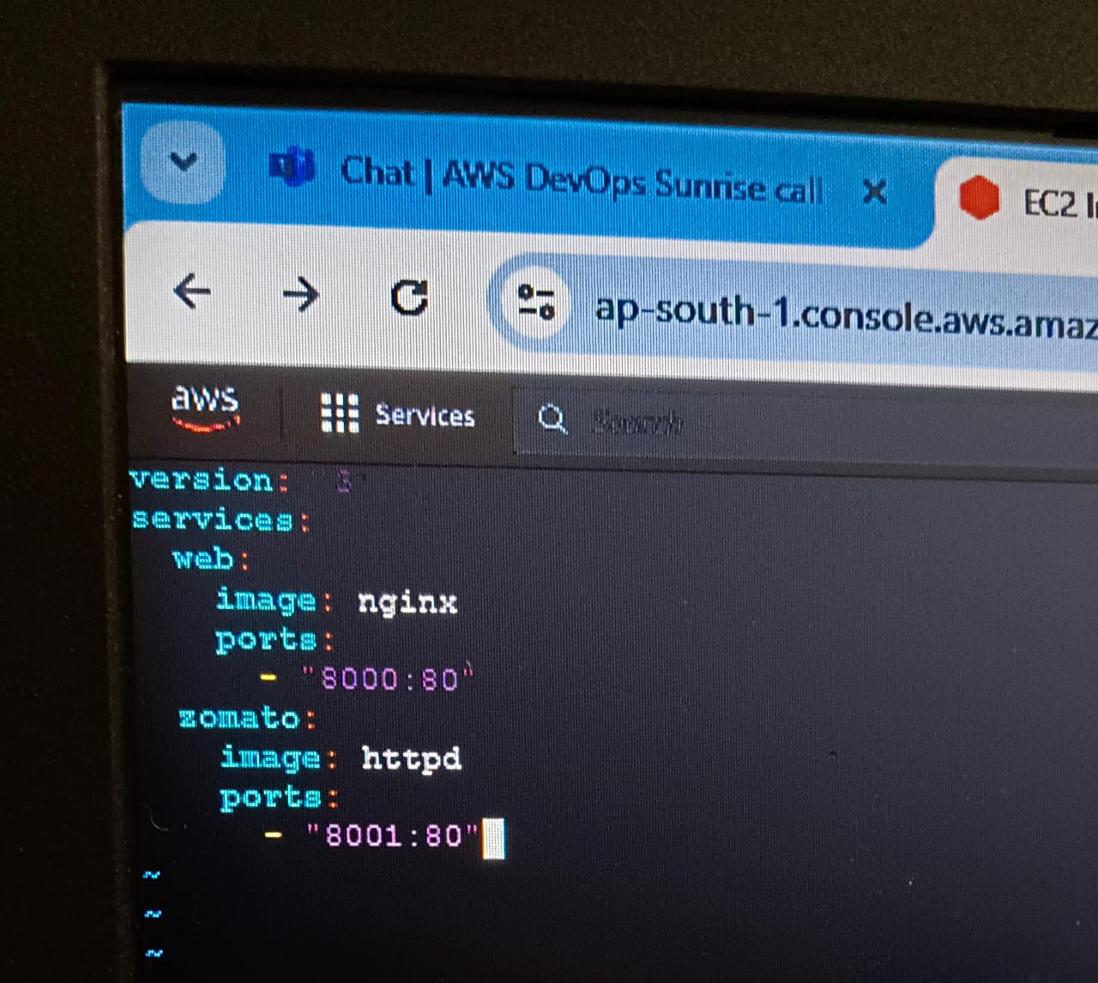
* GO TO GOOGLE SEARCH dockerhub login
* docker login
* username :
* password :
* 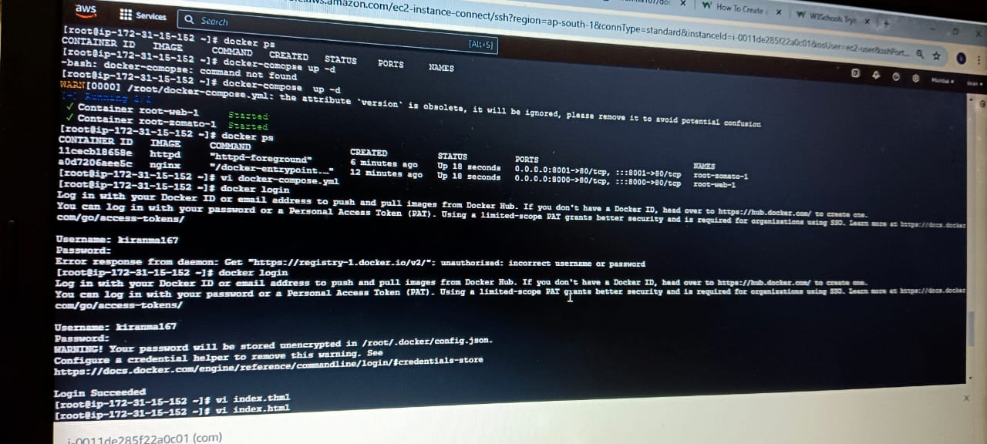
* Vi index .html
* 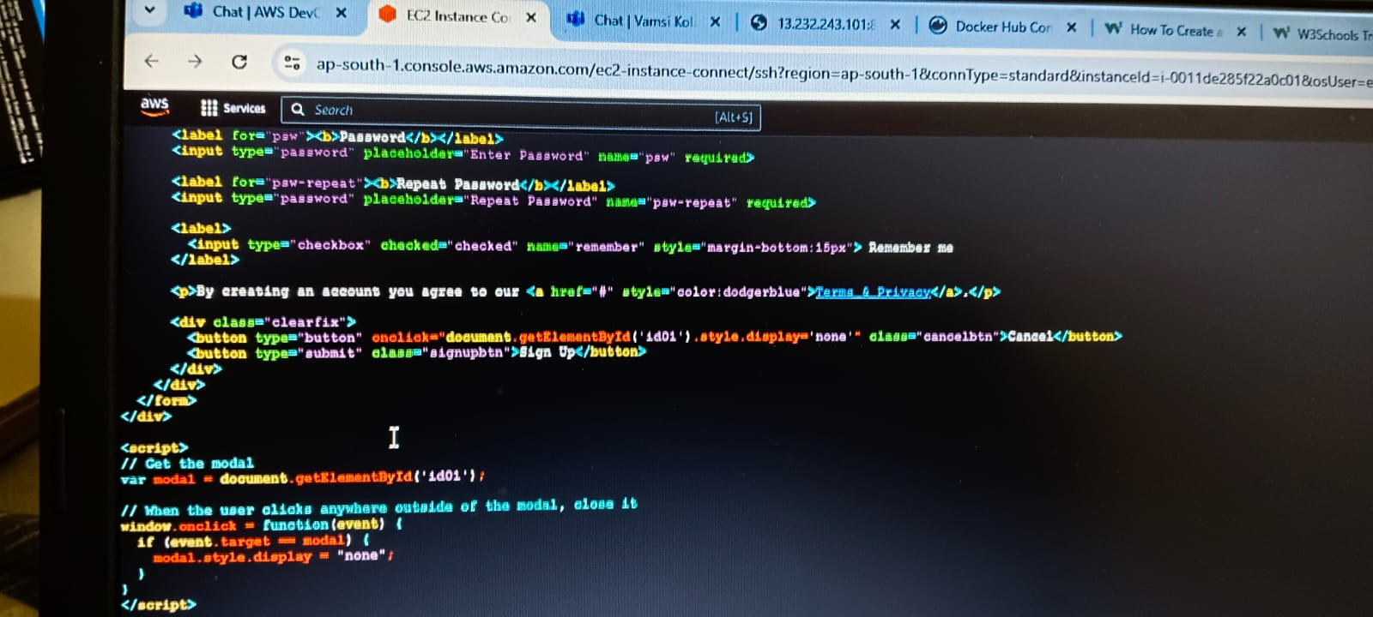

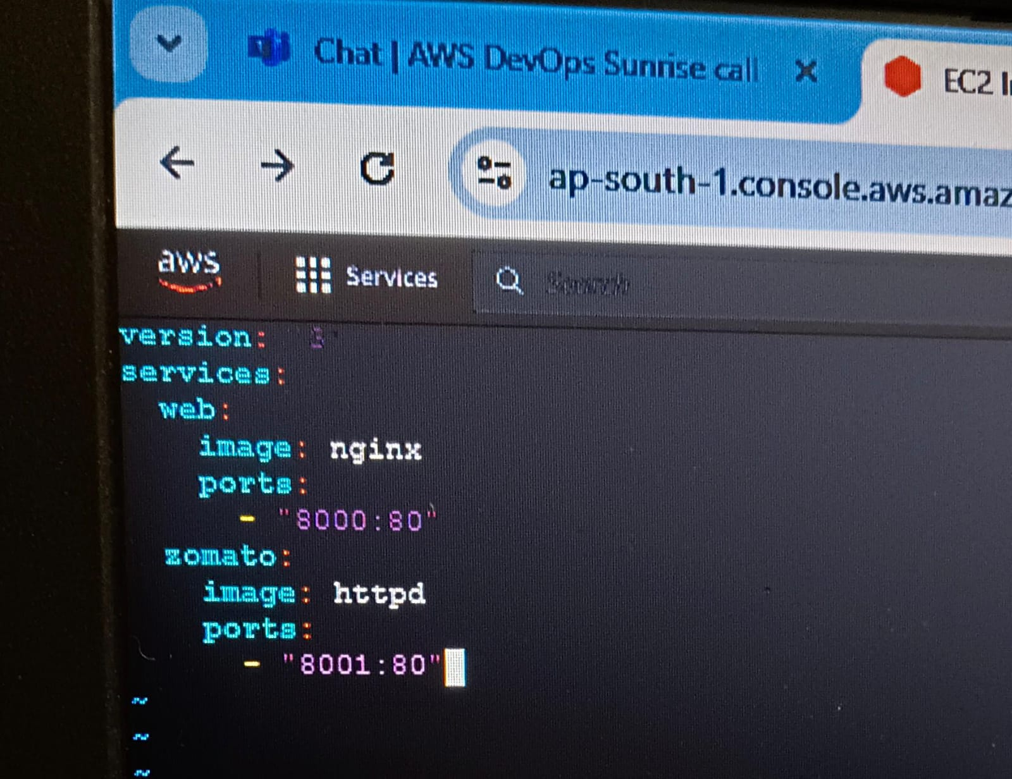

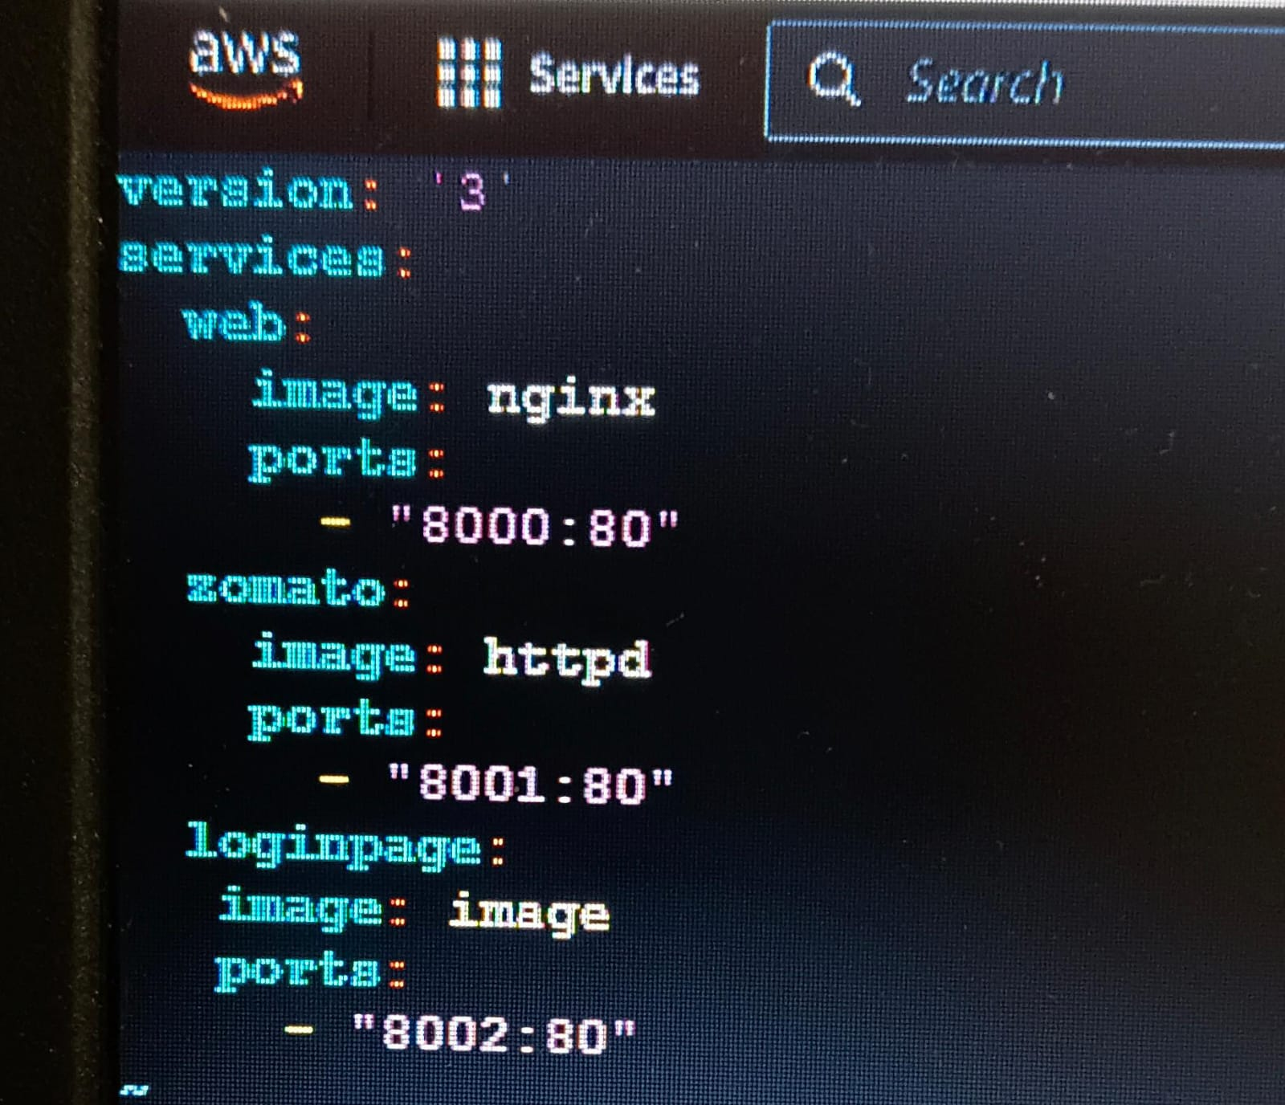

* Vi index . html
* Ll
* Docker login
* Vi docker-compose .yml
* Docker-compose up -d
* Docker ps

